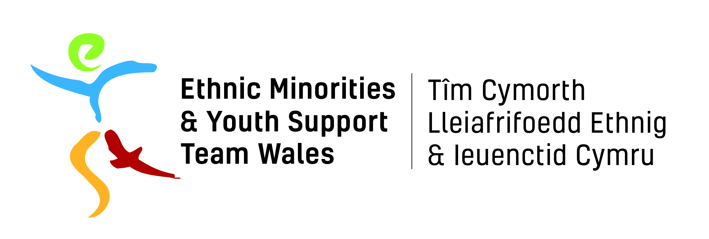

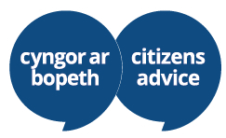

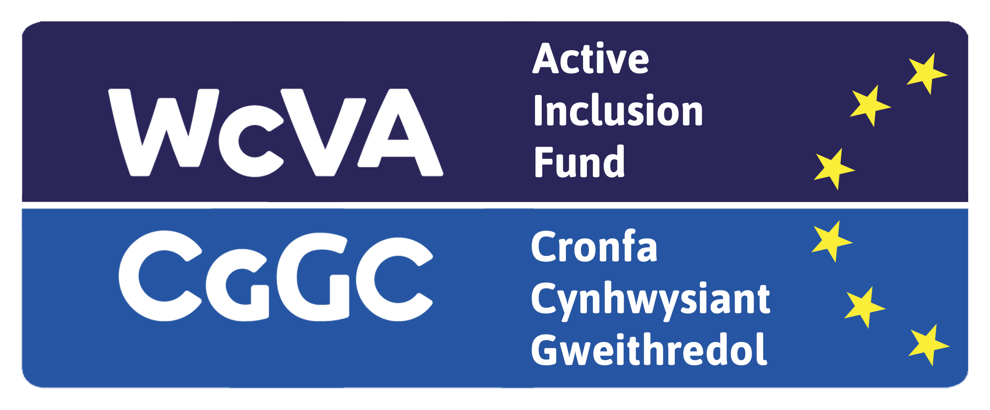

EYST Wales /Citizens Advice Swansea Neath Port Talbot

BME Invest Work Placement (Administrative Support - Swansea)

Job Description

Job Title: Administration Assistant

Hours of Work: 16 hours per week (to be worked over three days)

Location: Citizens Advice Swansea Office (Wind Street)

Salary: Real Living Wage

Responsible to: Steve Gray

Responsible for: Delivering an effective administrative service for advisers/clients

Citizens Advice Swansea Neath Port Talbot offers a free service that is confidential, impartial and independent of government or the local authority. We provide advice services for the general public on a range of matters including debt, money management, welfare benefits, employment, consumer, housing, family, immigration and general legal matters. We value equality and diversity and have been based in Swansea for over 80 years. We have 40 paid employees and around 37 volunteers.
We seek an enthusiastic and motivated individual to join our team delivering administrative support services to the advice team. We work with a diverse range of clients requiring the ability to work under pressure whilst dealing confidently and sensitively with our client group and our partners. Suitable candidates will have a commitment to the aims and principles of the service.

Aims of the Post

- After a period of training, you would develop the skills to be able to provide administrative services within the organisation including collating client feedback and statistical information and using innovative ideas to produce reports and campaign materials

Principal Accountabilities and Main Duties

- Assist advice staff by answering the telephone and refer calls or take messages, copying relevant information required for passing on to an adviser or the client
- Create, maintain and archive paper and electronic filing systems in accordance with the Citizens Advice systems and procedures
- Maintain and reorder stocks of stationery, leaflets and posters
- Maintain online and other electronic appointment diaries ensuring appointment times are agreed and communicated and any necessary support, including interpretation, is identified
- Update public information materials and information
- Use IT for record keeping
- With support and training: process client information collected at the reception helpdesk; maintain statistics and collate and produce reports to a prescribed format; follow up client cases and record outcomes e.g., amount of additional income gained/ debt written off
- To take part in training courses, staff meetings and regular supervision
- To work within relevant health and safety legislation
- To ensure the implementation of agreed information sharing protocols, and risk assessment procedures
- To ensure that the project promotes and reflects equality of opportunity at all levels
- To ensure that Safeguarding & Child Protection and all other relevant policies for EYST and CASNPT are implemented
- To uphold the confidentiality of information of clients
- Maintain high levels of professional standards
- To carry out any other duties that may from time to time be required

Person Specification

- A desire to work with the general public
- Good oral communication skills
- A confident and assertive personality
- Good level of IT confidence e.g. using email, Microsoft office & web browsing
- Ability to manage time and multi-task
- An understanding and commitment to equality, diversity and inclusion

Please Note

The work placement is organised by EYST Wales and hosted by Citizens Advice SNPT and is based in the Swansea (Wind Street) office.

We particularly welcome applicants from under-represented groups who are currently not in education, employment or training.

Applications for this vacancy are by online application form only, CVs are not accepted.

Start date: 7th February 2022

This Active Inclusion Vacancy is funded by ESF (European) funds managed by WCVA.

