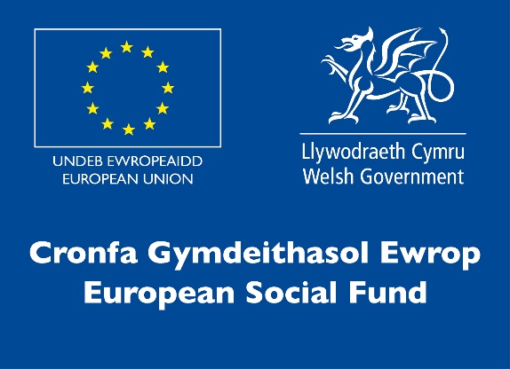
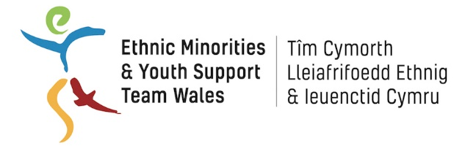

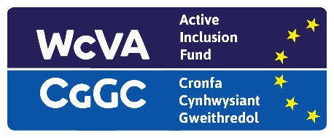

EYST Wales/VividBlock

BME Invest Work Placement

Job Description

Job Title: Creative and Marketing Assistant – Work Placement

Hours of Work: 16 hours per week

Salary: National Minimum/Living Wage (age dependent)

Tenure: Fixed term for 16 weeks

Responsible to: Taiwo Okeneye

Principal Accountabilities and Main Duties

Specific
The role will involve working on a variety of projects such as advertising campaigns, digital, flyers, posters, brochures and general advertising for the company.
- Creating artwork for social media assets across Facebook, Instagram, Pinterest and other channels in accordance with client brand guidelines
- Developing visual ideas and concepts for media campaigns and translating these into high quality artwork which delivers on best-practice
- Creating website and display assets for our client’s brands to bring their brand identity to life online, ensuring all output is on-brand
- Day to day and creative production including cropping, resizing and reformatting client assets to create suitable content for paid and organic marketing channels
- Internal design support for new business pitch collateral and VividBlock website
- Direct contact with clients and relationship management
- Managing and organising image libraries and artwork files using Google Suite
- Design promotional materials across all media, online and offline

General
- To ensure regular reporting and updates to partners within EYST as required
- To ensure the collection, entry and return of information as required for monitoring and evaluation
- To take part in training courses, staff meetings and regular supervision
- To work within relevant health and safety legislation
- To ensure that the project promotes and reflects equality of opportunity at all levels
- To ensure that EYST Child Safeguarding and all other relevant policies are implemented
- To uphold the confidentiality of information of clients
- To work with the wider EYST team to set and maintain a culture of high professional standards and to deliver best value services
- To carry out any other duties that may from time to time be required

Person Specification

- Aged 25+ currently not in education, employment or training
- Knowledge of creative packages, use of social media and Mac platforms
- Good interpersonal and customer service skills
- Good communication skills and a professional manner
- An understanding of and commitment to equal opportunities
- Ability to use social media including Facebook, Instagram and Twitter
- Experience in IT, including being able to use Email, Word, and the Internet
- Organised, focussed and self-motivated

Please Note

The work placement is organised by EYST Wales and hosted by VividBlock. This will involve working in line with current guidelines (social distancing, masks, PPE etc as required) due to the threat of COVID-19.

We welcome applications from applicants from a BME background who are currently not in education, employment or training and who are long term unemployed or economically inactive.

Applications for this vacancy are by online application form only, CVs are not accepted.

This Active Inclusion Vacancy is funded by ESF (European) funds managed by WCVA.

